Here I built a complex Dashboard by combining different DAX functions to solve a unique problem

Tables Used : Sales ,Store & Customer

**ANALYSIS**

Analysis on how good we are in delivering orders in different countries all around the planet.

To find the cumulative percentage of delivery orders (online) by number of delivery days.

Step 1 – Number of days required to deliver an order.

Calculated Coloumn :

Delivery_Days = INT ( Sales [Delivery Date] – Sales [Order Date])

Measures Used :

Here I used Filter function to find the Average number of delivery days required for Online orders

Avg_Delivery_Days = Averagex(

Filter(

Sales, Related (store[name] = “Online”

) ,Sales [Delivery Date] – Sales [Order Date]

)

Note :

Here the iteration is happening on the ‘Sales’ Table ,which does not contain Store[name] .’Store’ is a different table.So use Related DAX function to access Store[name] from ‘Store’ table as it has an active relationship with ‘Sales’ table.

**OR**

Avg-Delivery_Days=Calculate(

Averagex(

Sales,Sales [Delivery Date] – Sales [Order Date]

), Store[name] = “Online”

)

Calculate DAX Function lets you change the current filter context by introducing new filters.

In Sales Table a single Order Number contains lines of data.Need to group data by unique Order Number ,Order date & Delivery date coloumn to find the correct value for Avg_delivery_days.

Summarize Dax Function – This function can scan a table and perform grouping by set of coloumns provided.

Avg_Delivery_Days = Calculate(

Averagex(

Summarize(

Sales,Sales[Order Number],Sales[Order Date],Sales [Delivery Date]

),

Sales[Order Date]-Sales[Delivery Date]

),

Store[name] = “Online”

)

Step 2 – Percentange of delivered orders in online store

Orders = Calculate( distinctcount(Sales [order number]) , Store[name] = “Online”)

Percentage of Total Orders delivered removing the filter from delivery days.

Total Orders = Calculate (distinctcount( Sales[order number]) ,Store[name] = “Online”,

RemoveFillters(Sales [Delivery Days])

)

Pct_orders = Divide ( Orders / Total Orders )

**Exceution of above measure shows gives the below table**

Step 3 : To find the cumulative percentage of orders delivered in 1, 2 ,3,5,7,10 and 15 days

Find out the percentage of orders delivered in atmost 3 days

Pct 3 days = Calculate (Pct_Orders ,Sales (Delivery_days )<=3)

To find out percentage of orders delivered for 1,2,3,5,7 ,10,15 days, Create a table ‘Days’ .

Days = {1, 2, 3, 5, 7, 10,15}

Rename the coloumn values as ‘Days’

Selectcoloumns Dax function allows to select the coloumns and rename it.

Days = Selectcoloumns( {1,2,3,5,7,10,15} ,”Days”, [value])

Find the percentage X days grab the days value from the days table

Pct Xdays = Calculate (Pct_days , Sales [Delivery_days] < = Days [Days])

This measure does not work ,because there is no row context that provides values in to the ’ Days’ table.There is no iteration in this code

Selectedvalue Dax function allows to grab value from the table, provided it has a single value in the current Filter Context.

Pct X days=

Var X days = Selectedvalue (Days[Days])

Var Result =

Calculate (Pct_Orders , Sales[Delivery_days] < = Days [Days])

Return

Result

In the final visual , we want to see a 100% only once.We need to check a 100% was reached for the previous day ,if Yes then do not repeat the value.

Find the Previous days value

Pct X days=

Var X days = Selectedvalue (Days[Days])

Var Result =

Calculate (Pct_Orders , Sales[Delivery_days] < = Days [Days])

Var Prev_value = Calculate (max (Days[days]) ,Sales [Delivery_days] < = X days)

Now we got the Previous day ,find the previous day result

Pct X days =

Var X days = Selectedvalue (Days [Days])

Var Result = Calculate ([Pct_orders] , Sales[Delivery_days] < = Days[days]

Var Prev X days = Calculate (max ( Days [Days] ) ,Days[days] < X days)

Var Prev_Result = Calculate([Pct_orders , Sales[Delivery_days] < = Prev X days)

Return

Result

If (Prev_Result < 1 ,then Result)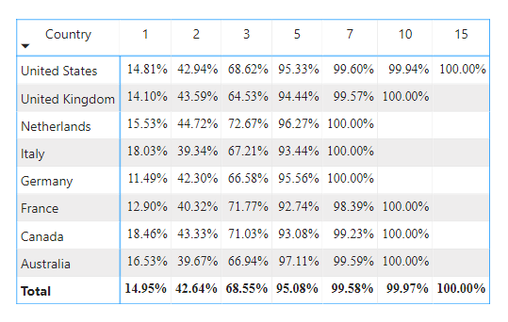

Step 4 : If the Percentage is above overall percentage then return +1 and when the percentage is below the overall percentage return -1.

Pct X days color =

Var Current Value = [Pct X days]

Var Total Value = Calculate ( [Pct X days] , Removefilters (Sales)

Var Result =

If (Current Value < Total Value ,- 1 , +1 )

Return Result

Do Conditional formatting on Pct X days color measure

After the application of Conditional Formatting ,obtained the Final visual.

